

**Cuantitative Finance Project Autumn 2023**

**Heston Model**

**Teacher: José Mario Zarate Carbajal**

**Members:**

**Espinosa Carabez Arturo**

**Larrauri Ocegueda Maximiliano**

**Ramírez Rojas Gonzalo Artemio**

**TABLE OF CONTENTS**

INTRODUCTION 3

WHAT IS NEEDED TO UNDERSTAND THE HESTON MODEL 4

METHODOLOGY 7

1. Obtaining the prices of an asset and/or index: 7

2. Obtaining the input parameters that we need to provide to our Heston model function: 7

3. Working procedure of our function that generates Heston price and volatility simulations: 9

RESULTS AND ANALYSIS 10

1. Trajectories graphs and their explains: 10

2. Black&Scholes and the function to obtain puts and calls: 14

3. Show two different scenarios with positive $ρ$ and negative $ρ$: 20

4. Implied volatility function and volatility curves 21

5. Two Different Ways to Obtain the Smile Volatility: 23

6. Volatility Surface with B&S 26

7. Graphical User Interface 28

CONCLUSIONS 30

REFERENCES 32

# **INTRODUCTION**

In this project, we will address the Heston model, using it in a slightly more generalized manner. What do we mean by this? Well, we have decided to create a model project where anyone interested in obtaining option prices that consider volatility variations can have a foundation and guide to do so without any difficulty and can obtain a comprehensive analysis of it for a specific asset of their choice. Later, we will explain and delve further into this process. However, it is essential to mention first, what is the Heston model?

The Heston model is an option valuation method that takes into account the variations in volatility observed in different options traded for the same asset at a given moment. It attempts to replicate market prices using stochastic processes to model volatility and interest rates.

(Activos, 2023)

We will delve further into the procedure and everything we need to consider to carry out this model. Further down we will present the necessary equations to enable the simulation of prices and volatilities for subsequent use in option pricing calculations. It's worth noting that we are working on all of this in the Python language because it is an excellent tool widely used in most financial-focused companies today, and it's freely available to all programming beginners. It is a very user-friendly tool. Additionally, we will showcase a series of tables and graphs essential for understanding how this model works in our specific project. Our goal is to achieve a stochastic solution where we analyze the movements of our prices and the volatility in relation to the behavior of any asset we wish to analyze.

# **WHAT IS NEEDED TO UNDERSTAND THE HESTON MODEL**

The model was named after Steven L. Heston, a mathematical economist and business professor who holds a Ph.D. in finance from Carnegie Mellon and has held teaching positions at various universities, including Yale and Columbia. He proposed the model that bears his name in his 1993 article, "A Closed-Form Solution for Options with Stochastic Volatility with Applications to Bond and Currency Options," published in The Review of Financial Studies.

In theory, the volatility implied by the price of each option should be the same for all these options because they are all based on the same underlying asset. Some option pricing models, such as the Black-Scholes model, make this assumption and use the implied volatility of an asset to predict option prices at any strike price. Others, like the Heston model, first model volatility and then draw conclusions about prices.

(Activos, 2023)

It is important to mention that options derive their values from the expected gain that the option holder may obtain, which depends on the price and volatility of the underlying asset.

The Heston model is a stochastic volatility model where it is assumed that the asset's volatility is not constant, not even deterministic, but follows a random process. This model is based on a system of two coupled stochastic differential equations that represent the dynamic behavior of the underlying asset and the dynamics of volatility. These equations involve correlated Brownian motions and can be expressed as follows:

$$\left(1\right) dS_{t}=μS_{t}dt+\sqrt{v_{t}}S_{t}dW_{t}^{S}$$

$$\left(2\right) dv_{t}=k\left(θ-v_{t}\right)dt+ξ\sqrt{v_{t}}dW_{t}^{v}$$

$dW_{t}^{S}$ and $dW_{t}^{v}$ are Weiner procesess with instantaneous correlation $ρ$

(John, 2023)

But what does each term in our equations mean? The first equation corresponds to changes in price, that is:

1. **Price Change $(dS_{t})$:** This term represents the infinitesimal variation in the price of the underlying asset over an infinitesimal period of time **𝑑𝑡.** In other words, it shows how the asset's price changes in a very small instant.
2. **Asset Price ($S_{t}$):** This is the current value of the underlying asset at time t. It is the price we are trying to model and predict.
3. **Expected Rate of Return ($μ$** ): It indicates the rate at which the asset's price is expected to increase on average over time. It represents a trend in the asset's price growth.
4. **Stochastic Volatility ( $v_{t}$):** This is the volatility of the asset's price, which changes randomly over time. Volatility measures how "volatile" the asset's price is. In the Heston model, volatility is an essential component and behaves stochastically.
5. **Stochastic Noise Source ( $dW_{t}^{1}$):** This term represents the random component in the equation. In the context of the model, $dW_{t}^{1}$ is a stochastic process that introduces randomness into the asset's price. It's like a random "kick" that affects the asset's price.

The second equation corresponds to changes in volatility, and each term represents the following:

**Volatility Change ($dv_{t}$):** This term refers to the infinitesimal variation in volatility over a very small time period (dt). In other words, it tells us how much volatility changes in a very brief moment in time.

**Current Volatility ($v_{t}$):** This is the level of volatility at time t. In the Heston model, volatility is not constant and can change over time. This equation describes how it evolves.

**Reversion Speed ($κ$):** This parameter controls how quickly volatility returns to a long-term, stable level represented by $θ$. If κ is high, volatility returns to $θ$ more rapidly.

**Long-Term Volatility (θ):** This is the level at which volatility tends to stabilize over time. $θ$ is determined as the "average" level at which volatility wants to be in the long term.

**Volatility of Volatility (σ):** This parameter measures how much volatility changes in itself. If $σ$ is high, the volatility $v_{t}$ varies more intensely over time.

**Stochastic Noise Source ($dW_{t}^{2}$):** Similar to the noise in the price equation, $dW_{t}^{2}$ is a stochastic process that introduces randomness into volatility. It's like a "source" of uncertainty that affects how $v_{t}$ changes.

(Freddy H. Marín Sánchez, 2023)

As we have seen, this model will help us obtain simulations of *n* prices and *n* volatilities for any asset of interest, allowing us to subsequently calculate option prices and conduct a market comparison and analysis. Furthermore, the advantage is that we can apply it to any asset and/or index of our choice. But how is this achievable? Well, we will show that next.

# **METHODOLOGY**

## **Obtaining the prices of an asset and/or index:**

The first thing we did in the modeling process was to obtain the prices we wanted to work with for a specific asset or, if preferred, for an index. We obtained them with the help of the "**yahoofinancials**" Python library. It's important to emphasize that you can work with any asset of your choice. The Python code we created is automated in a way that the only things that need to be changed are the ticker of the asset of interest and the start and end dates of the period to be analyzed.

Here's how the only three lines of code that need to be changed look:

ticker = **"AMZN"**start_date = **"2018-10-11"**end_date = **"2023-10-10"**

We decided to choose the company Amazon because it is a massive, globalized industry with a presence in over 180 countries, more than 1,500,000 employees, and a net profit of 11,588 million. It is a well-established company in terms of financial figures and volatility numbers, which is why we chose to use it as an example.

(Wikipedia, 2023)

## **Obtaining the input parameters that we need to provide to our Heston model function:**

In the next step, we will show the code with the Heston model function, but before that, it is essential to mention how we obtain the parameters required by this function. These parameters are those seen in equations 1 and 2. There are various ways to obtain them, but we did it in a historical manner, meaning, we used the information from our data, which is obtained as follows:

1. From our dataset with historical information spanning 5 years, we took the "adjclose" and grouped it by month to have the prices aggregated for each month over those 5 years. We then calculated the standard deviation (volatility) from these prices.
2. Having these volatilities, we used the **first data** point as $v_{0}$.
3. The **last data** point represents our long-term volatility, which is $theta θ$**.**
4. For our monthly volatilities, we calculated the logarithmic returns (slope formula), and the average of these logarithmic returns gave us $kappa κ$**.**
5. Next, to obtain $sigmaV$, we calculated the volatility of our list of monthly volatilities.
6. Once we had our logarithmic returns for volatilities, we needed to aggregate the prices by month again over the 5 years. With the pure prices without their volatilities, as in step 4, we obtained the logarithmic returns. By having logarithmic returns for both prices and volatilities, we calculated the correlation between these logarithmic returns (prices and volatilities) to obtain $RhoSV$.
7. We used the risk-free rate $r$ from U.S. Treasury bonds.
8. **𝑆** equals the last closing price of the prices we are working with.
9. $T$ equals the period in years, and we chose 1 year.
10. **Npaths** and **paths** represent the number of trajectories to generate and the number of steps to choose in time discretization, respectively. The choice of these values is at the discretion of the person conducting the analysis.

## **Working procedure of our function that generates Heston price and volatility simulations:**

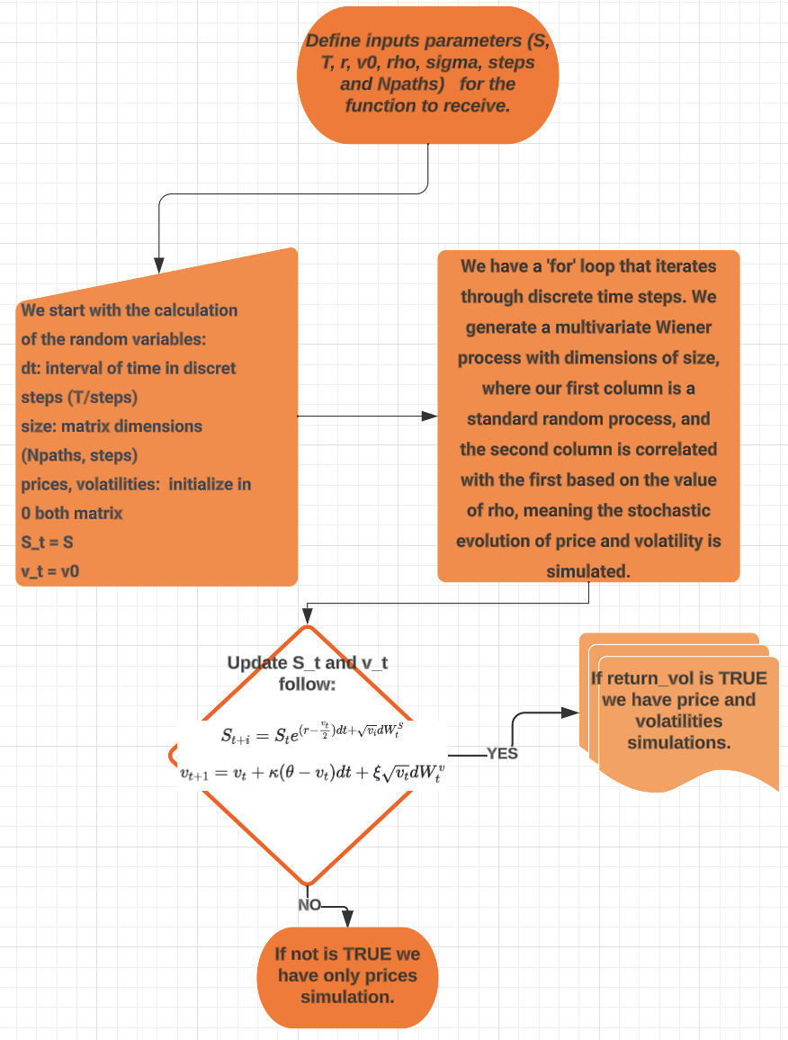Image 1. Function Heston working in Python

# **RESULTS AND ANALYSIS**

## **Trajectories graphs and their explains:**

With this, we can obtain simulations of 5000 prices and volatilities with a step equal to 252 because there are typically 252 trading days in a working year. This allows us to contextualize it to the market's reality.

As a result, we have the following graphs:

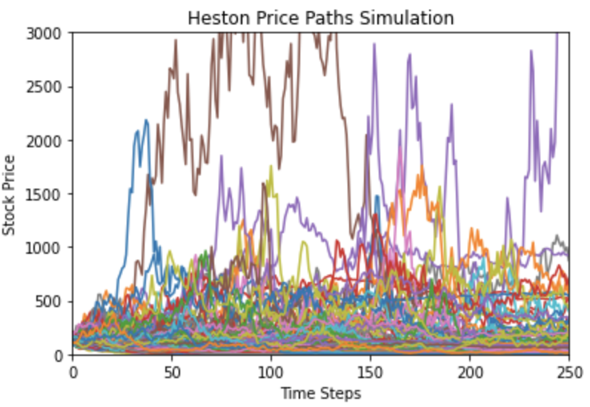Image 2. Price Simulations (5000) with Heston model

Here, we have the simulation of 5000 prices. It may be a bit challenging to visualize all the trajectories because there are many of them, but this helps us gain an understanding of how the prices behave with the model. Each line represents a different trajectory, and we can observe how stock prices fluctuate in these trajectories as time progresses. This is useful for comprehending the variability and uncertainty in stock prices according to the Heston model.

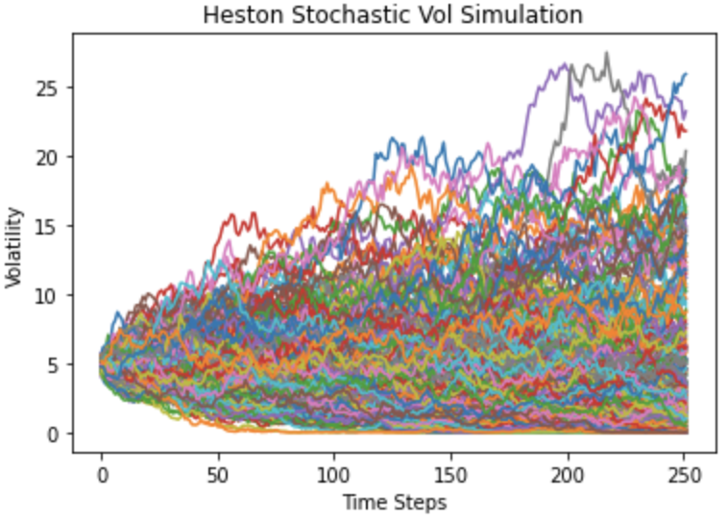Image 3. Volatility Simulations (5000) with Heston model

In this case, visualizing all the volatility trajectories is even more challenging. We can see that many of them behave quite similarly, and they also fluctuate as time progresses. None of them go below 0, which is expected because we initialized our S to the last closing price, and for any asset, it wouldn't make sense for its volatility to go negative in the stock market. We can observe peak volatilities exceeding 25, which makes sense given that our initial and final volatility values were 4.94 and 1.71, respectively.

Due to the reasons mentioned above, we decided to create two additional graphs with only 10 trajectories each for a more detailed analysis and improved visualization. Therefore, we have:

Image 4. 10 price simulations with Heston model

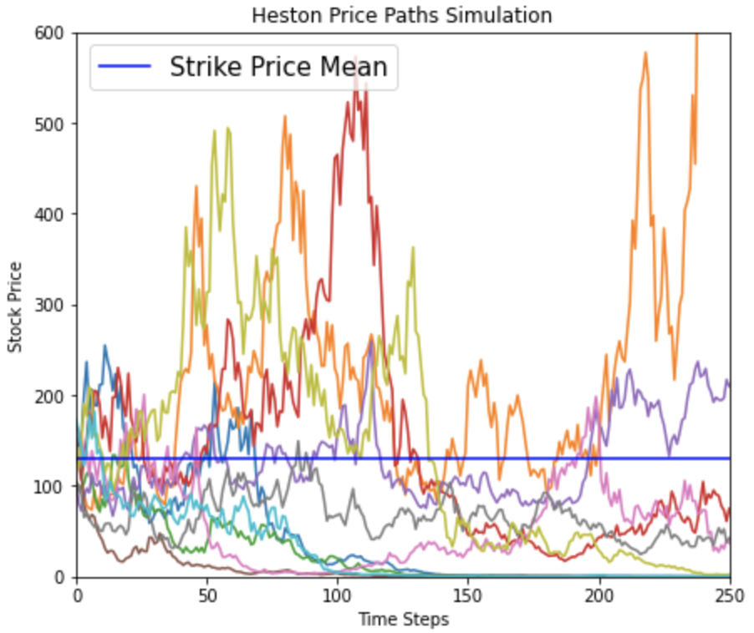

We created this graph with only 10 trajectories for better visualization (it's worth noting that this is automated in the code for this project, and with any asset, it can show you 10 simulations after the 5000 already shown). We can see how some trajectories start from the selected closing price (128.26). The blue line represents the mean of our Strike Prices series, which is equal to $128.26. These strike prices range from 30% below to 70% above this level to create a list of 20 possible values. We can see that the maximum touches $600, representing a growth of over 450%. Beyond this blue line, prices that move upwards would provide an indication of profit because if it's set at $128.26 and in the market, it reaches these levels, it would be beneficial for us. The same goes for selling; prices that fall below this K would generate a profit for us because we can sell our option at a higher price.

Image 5. 10 volatilities simulations with Heston model

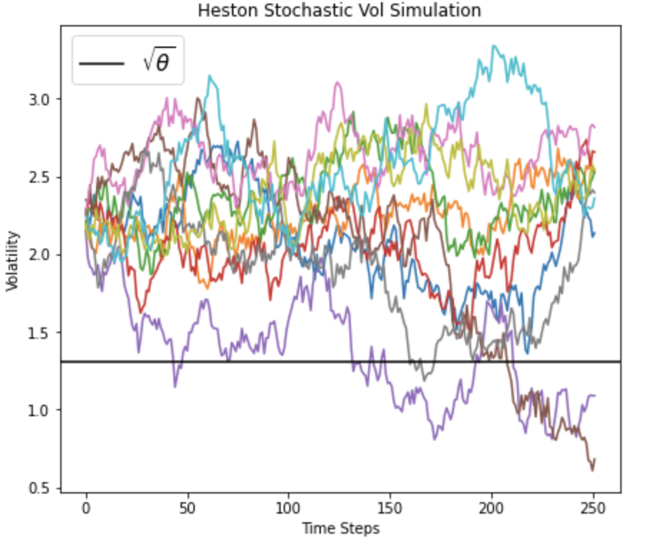

Just like in the previous graph, we have 10 volatility trajectories, but this time the horizontal line in the graph represents the long-term volatility, which is represented by θ in the Heston model. It is simply the square root of θ and is used to display this value on the same scale as volatility on the Y-axis. The black line is a constant reference that indicates the level of long-term equilibrium volatility in the Heston model. In other words, it shows the value to which volatility tends to stabilize over time. We can observe how these 10 trajectories hardly fluctuate above the long-term volatility, but in the first graph, we can see how they tend to approach this value over time.

## **Black&Scholes and the function to obtain puts and calls:**

With our price and volatility trajectories, we can now use them to calculate the prices for our put and call options, taking different values for K. In other words, we provided 20 possible values to have 20 scenarios, each with 5000 simulations. These values range from 30% below our strike price to an additional 70% above the strike price, in our case, the values range from 38.47 to 218.04. But it's necessary to explain how our function works to obtain option prices (puts and calls).

Well, our function is based on the **Black-Scholes** model. This is a mathematical model used in finance to determine the theoretical price of financial options. It was developed in the 1970s by three economists: Fischer Black, Myron Scholes, and Robert Merton and has become a fundamental framework in financial theory and option valuation.

The Black-Scholes model is primarily used to calculate the price of two types of options:

**Call Options:** These options grant the holder the right but not the obligation to buy an underlying asset at a specific price (called the strike price) on a specified future date. The model is used to estimate the price of a call option.

**Put Options:** These options grant the holder the right but not the obligation to sell an underlying asset at a specific price on a specified future date. The model is used to estimate the price of a put option.

It is based on the following key assumptions:

* Market prices are efficient and follow a geometric stochastic process, meaning prices change continuously and follow a log-normal distribution.
* There are no transaction costs or trading restrictions.
* There are no dividends paid by the underlying asset during the option's life.
* Interest rates are constant and known.

(López, 2020)

We have a function that uses the Black-Scholes model to calculate the put and call option prices. How do we do that? Well, the following diagram explains how it's done, following some formulas from the model to obtain our option prices according to our preferences.

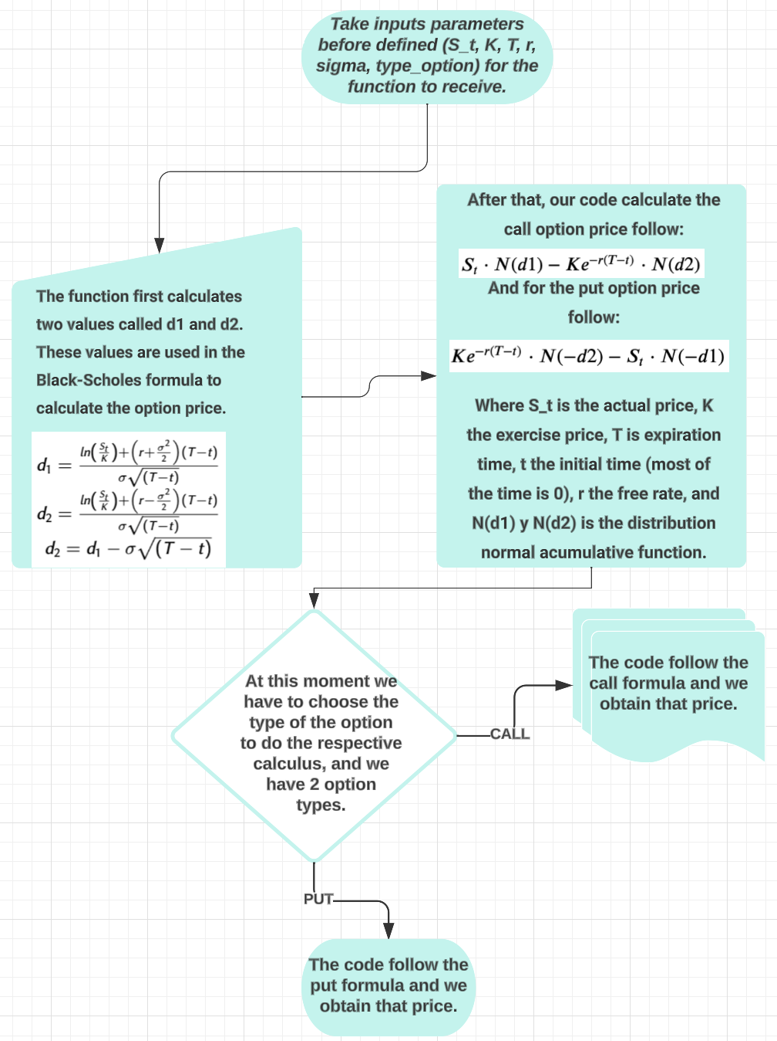Image 6. Option prices function follow Black&Scholes

Taking this into account, we understand how this function works, and thus, we were able to obtain our put and call prices not just for one Strike Price (K), but for 20, as mentioned earlier. We chose a range from 30% below to 70% above, allowing us to iterate through each of these values and obtain 5000 simulations for each one. Here are the results:

Table 1. Call and Put prices for each K_value

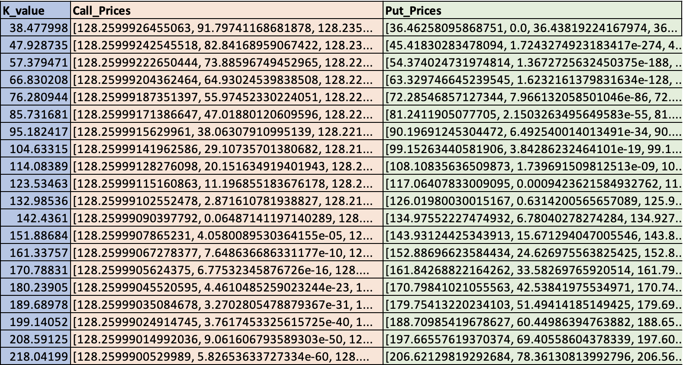

We can see all the **K_values** within the range of values we mentioned, along with all the possible calls and puts for the same Spot Price while iterating through the 5000 volatilities.

Just as a clearer example, we wanted to obtain another table simulating only one price for each **K_value,** using our initial volatility to put it into a shorter context, and we obtained the following:

Table 2. Call and Put price for each K_value

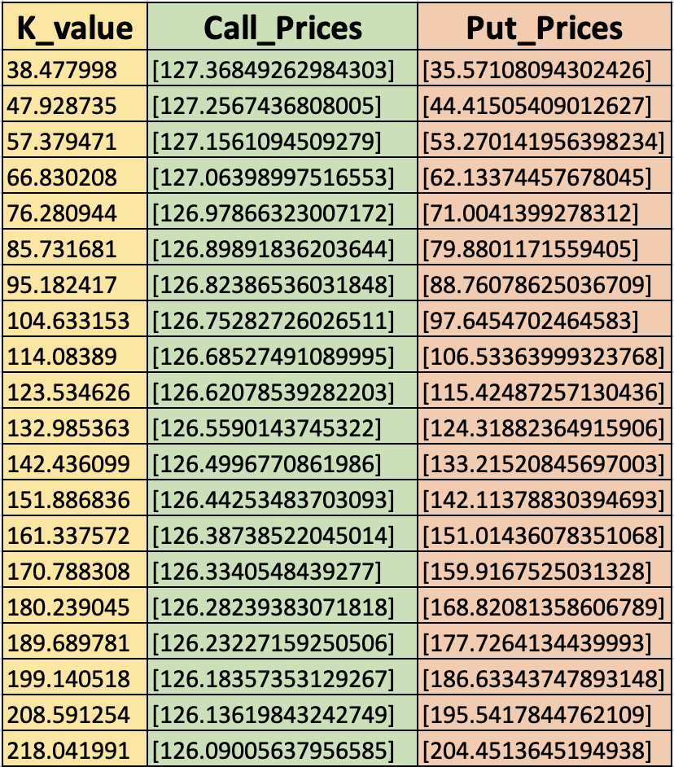

We can see how our table makes sense because it aligns with the reality and the correct functioning of options. In the case of call options, those starting with higher strike prices and lower spot prices are generally known as "out-of-the-money" options. This means that, at that moment, the strike price is above the current price of the underlying asset. These options are typically cheaper because the market does not expect the underlying asset to reach that strike price before the expiration date. As the strike price increases, call options become more "in-the-money," meaning the strike price is closer to or even below the current price of the underlying asset. These options are more expensive due to the increasing probability that the asset will reach or exceed the strike price.

On the other hand, put options follow the opposite logic. Those starting with lower strike prices and higher spot prices are usually "out-of-the-money" for put options. As the strike price increases, put options become more "in-the-money" and, therefore, more expensive.

This price structure reflects market expectations and the perceived probability of the underlying asset reaching certain price levels. Investors can select options with strike prices that fit their specific outlooks and strategies.

It's essential to remember that these price structures can change over time as market conditions and expectations evolve. Therefore, investors should conduct careful analysis and understand how options work before making investment decisions.

## Show two different scenarios with positive $ρ$ and negative $ρ$:

Now that we have our function that simulates trajectories, it's useful to visualize what would happen if it were positive and negative, considering that this is the correlation between the logarithmic returns of our prices and volatilities. We obtained the following:

Image 7. Two different rho’s (positive and negative)

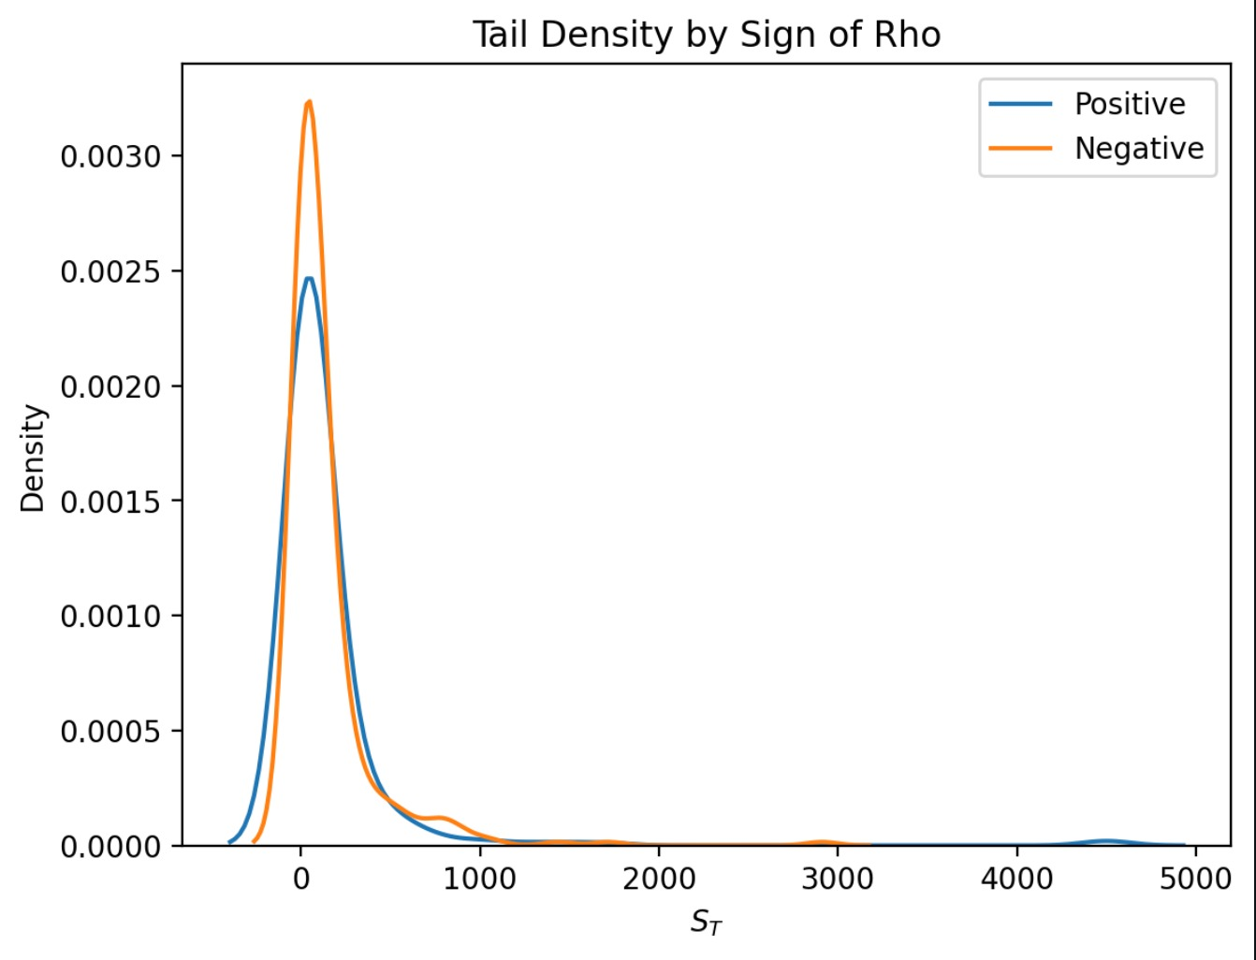

This graph shows how the probability density of final underlying asset prices varies when you change the correlation ($ρ$) in the Heston model. The shape of the distribution and the tails (extreme values) can change depending on whether the correlation is positive or negative. There aren't too many significant differences between them, except for small ups and downs. This is important in risk analysis and option valuation because correlation can affect the probability of extreme events in financial markets.

## **Implied volatility function and volatility curves**

We have created a function that is used to calculate the implied volatility of a financial option based on its market price and other parameters. Here is how it works in detail:

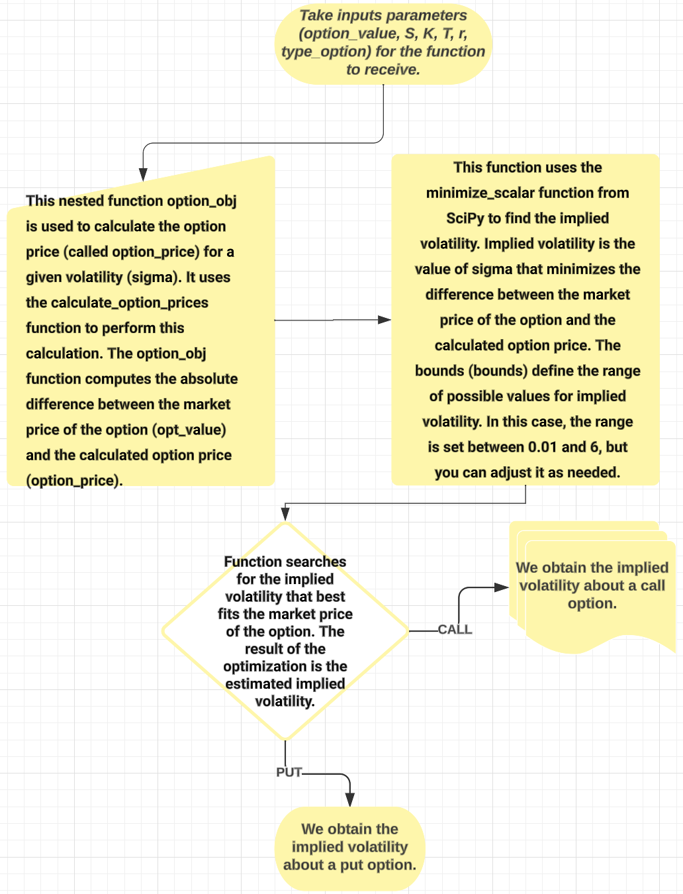Image 8. Implied volatility function working

Map and function created with the help of: (John, Calculating the Volatility Smile, 2021)

Implied volatility reflects the market's expectations regarding the future variability of an asset. In other words, it indicates what the market currently thinks about the future probability distribution of the asset.

When uncertainty in financial markets is high, it is generally believed that future return variability will also be high, and thus implied volatility is higher. Likewise, when uncertainty is low, it is commonly believed that future return variability will be low, and implied volatility decreases. However, implied volatility only represents the investors' perspective; there is no guarantee that this market perspective will become a reality. Implied volatility is about probability, not certainty.

(TomasGarciap, 2019)

## **Two Different Ways to Obtain the Smile Volatility:**

With our function for obtaining implied volatility, we wanted to use it in two different ways. One way is to use the already defined and explained function to calculate option prices using the Black-Scholes model. The other way involves using the mean of the maximum difference value between each K_value and the negative prices (negative rho) brought to present value for puts, and similarly for calls, but with the difference between positive prices (positive rho) and each K_value, also brought to present value.

And how do these two ways of obtaining the smile volatility look?

Using the formula to obtain option prices with Black-Scholes:

Image 9. Smile Volatility with Black&Scholes

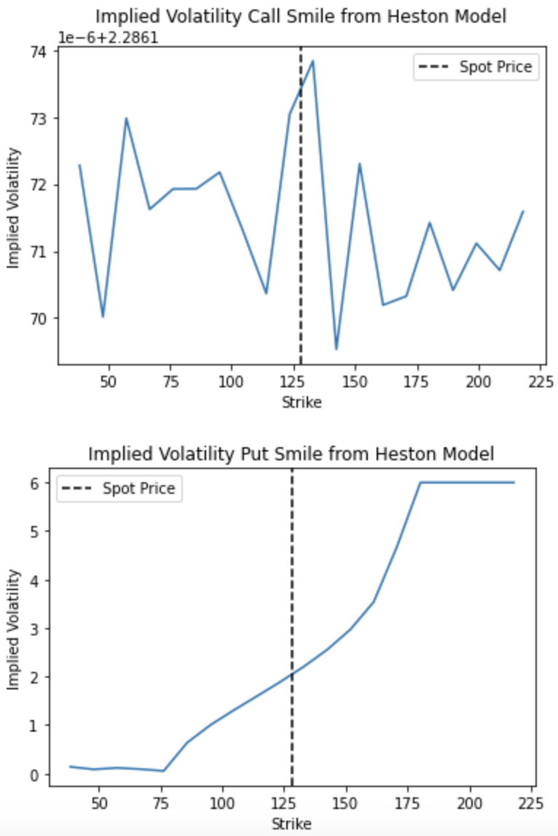

With the mean of the maximum value:

Image 10. Smile Volatility with Mean of Maximum Value

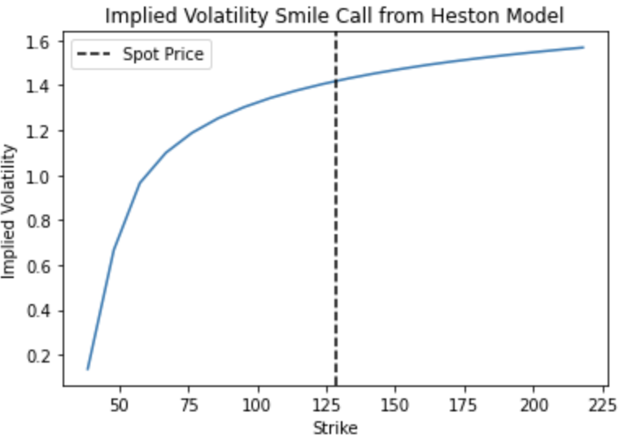

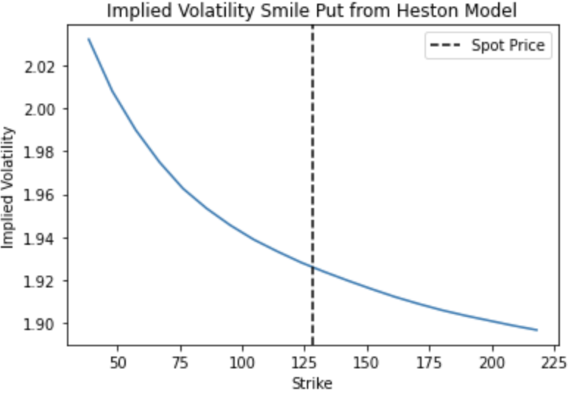

The reason for using the mean-max function to calculate the values of call and put options instead of directly using the price generated by the Black-Scholes function is to calculate the average value of options over multiple simulated price paths.

In the context of option valuation in stochastic volatility models like the Heston model, multiple simulations of underlying asset prices are generated to represent market uncertainty. Each simulation results in a different option price based on the final prices of the simulations and the strike price.

The mean-max function (prices_pos - K_value) is used to calculate the value of call options, meaning that only the positive value is considered when the final price of the simulation ("prices_pos") is greater than the strike price ("K_value"). In other words, it calculates the intrinsic value of the call option (what you would gain if you exercised it) in each simulation.

Similarly, the function (K_value - prices_neg) is used to calculate the value of put options, meaning that only the positive value is considered when the strike price ("K_value") is greater than the final price of the simulation ("prices_neg").

Then, the average value of the options in all simulations is calculated to bring the values to present value, considering the risk-free interest rate ("r") and the time to expiration ("T").

In summary, the calculation of call and put options in each simulation and the taking of the average value is done to represent the expected value of the option in a stochastic volatility environment. This approach is essential for valuing options in stochastic volatility models like the Heston model. Then, implied volatilities are calculated from these values using the implied volatility function presented earlier.

Clearly, we can see that the curve is much smoother and looks better when we use the mean-max function. It is much easier to visually identify how our strike price increases and surpasses the spot price as implied volatility grows and the same for the puts, where the strike price increases as implied volatility decreases.

## **Volatility Surface with B&S**

Finally, we want to show a volatility surface chart. What is this? It is a three-dimensional graph that represents the implied volatility of financial options as a function of two variables: the strike price and the time to expiration (tenor). In other words, it shows how implied volatility changes as these two key factors vary.

Put:

Image 11. Put Implied Volatility Surface

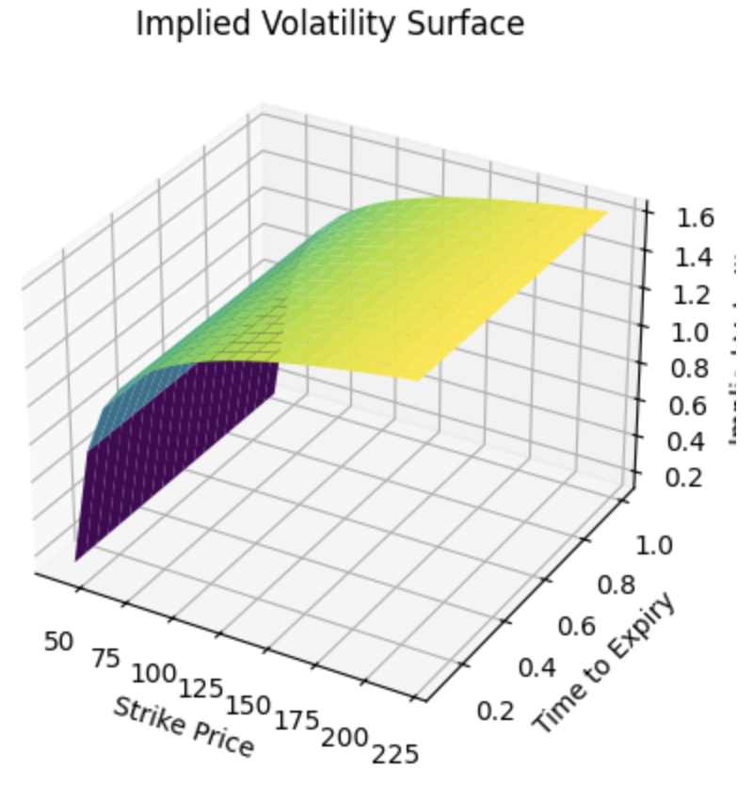

Call:

Image 12. Call Implied Volatility Surface

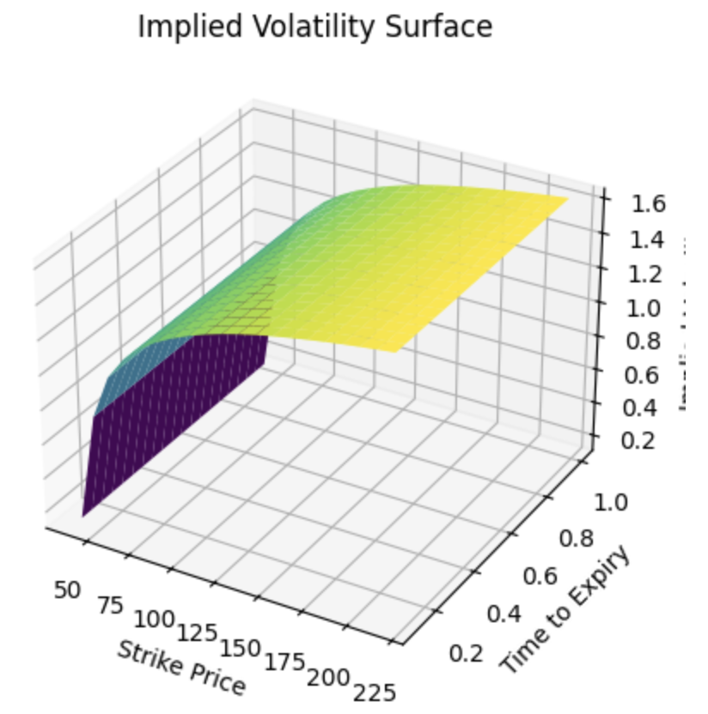

The "Implied Volatility Surface" chart shows how implied volatility varies with the strike price (x-axis) and the tenor, which we chose as one year (time to expiration, y-axis). Implied volatility is a measure of the market's expectation regarding the future volatility of the underlying asset.

On the x-axis (Strike Price): It represents different options' strike prices. Each point along the x-axis corresponds to a specific strike price.

On the y-axis (Tenor or Time to Expiration): It represents the time remaining until the options' expiration. Each point along the y-axis corresponds to a specific tenor value.

On the z-axis (Implied Volatility): It represents implied volatility. The higher the value on the z-axis at a specific point on the surface, the higher the implied volatility associated with that strike price and tenor.

Colors can indicate the magnitude of implied volatility, with darker colors possibly representing higher volatilities.

This chart is especially useful in the context of financial option valuation, as it allows you to visualize how market participants perceive future volatility in different scenarios. For instance, you might observe that implied volatility is higher for options with a specific strike price in a longer tenor, reflecting greater uncertainty in the market over a longer time horizon. This graph appears in that form because we are using B&S model.

## **Graphical User Interface**

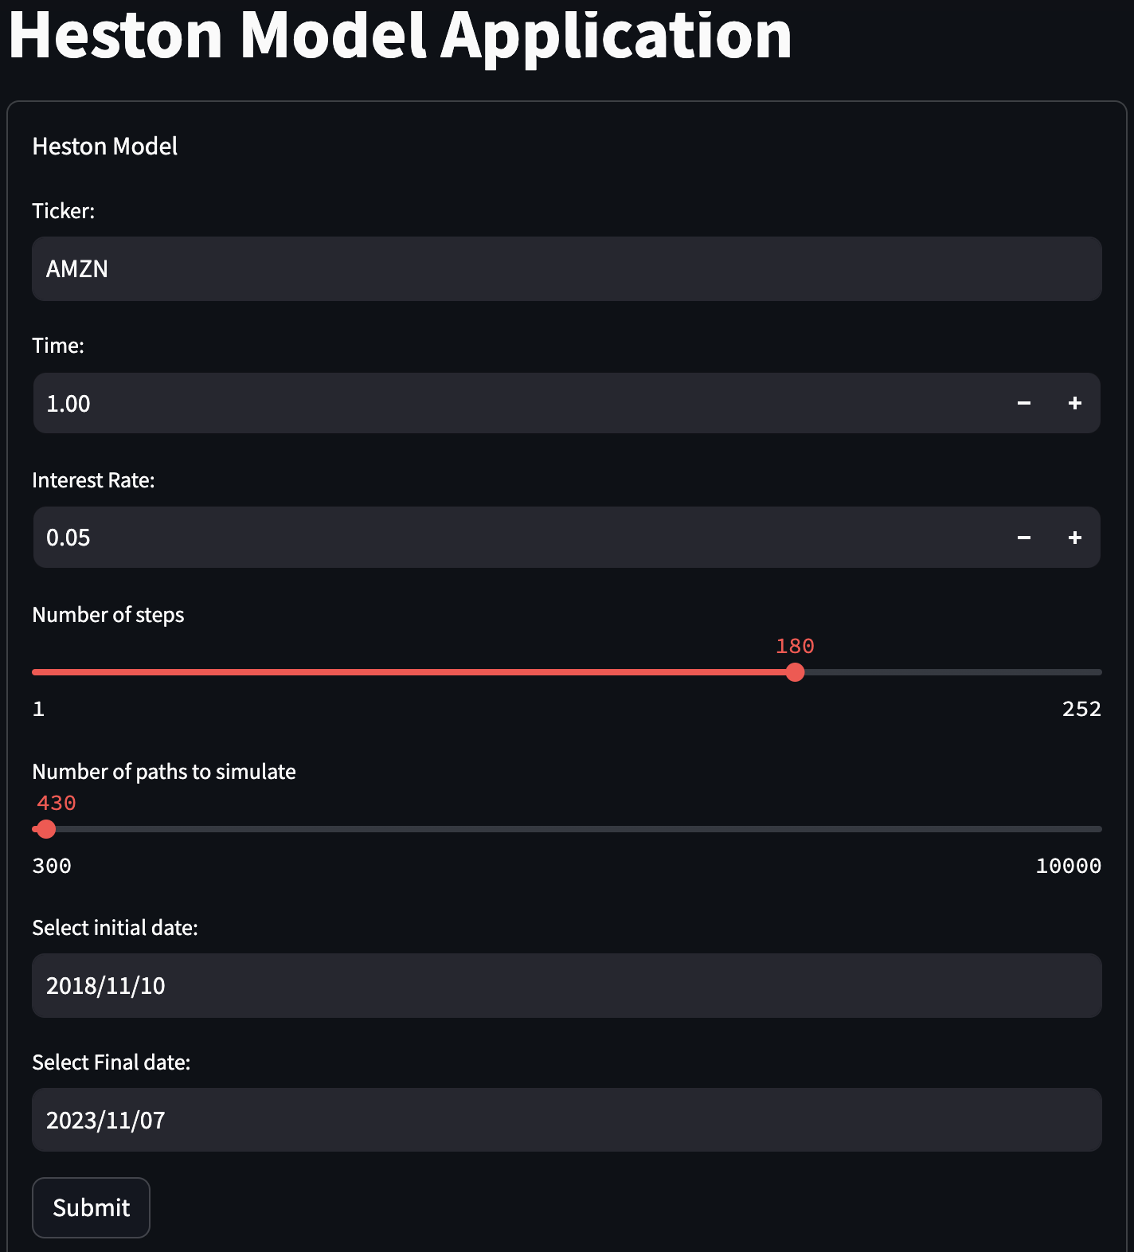Image 13. Graphical Interface

As we can see, you can visualize an interface where you can Select the ticker you want to analyze, the time horizon in years, the risk-free interest rate, the number of steps from 1 to 252, and the number of simulations you'd like to visualize, ranging from 300 to 10,000. Lastly, and very importantly, specify the start and end dates for your observation period and analysis. This will allow you to obtain a summarized analysis of everything presented in this document, including both graphs and tables, enabling you to access data from such an interesting project in a matter of seconds and easily switch between different companies.

# **CONCLUSIONS**

With the completion of this project, we were able to gain in-depth knowledge of the Heston model. We learned that a predictive model for simulated prices and volatilities, considered stochastic and not constant over a given period of time, can help us determine call and put option prices, as needed.

* The Heston model is a powerful tool for modeling the volatility of financial asset prices in a more realistic manner than the Black-Scholes model. It allows for a better capture of the volatility smile and abrupt market movements.
* The Heston model has a significant impact on options valuation. Call and put options are valued differently compared to the Black-Scholes model due to stochastic volatility.
* The results of the Heston model are sensitive to parameter values, such as the mean reversion rate, long-term volatility, and the correlation between prices and volatility. Small changes in these parameters can have a substantial impact on the outcomes.
* Calibrating the Heston model to market data is an important and challenging task.

We are delighted to have accomplished a project that's highly automated in terms of code, as it simplifies the subsequent analysis of various data. The key takeaways from this project include:

* Having a function that provides historical data for the desired timeframe.
* Calculating optimal parameters for the Heston function and ensuring it functions correctly.
* Running simulations of prices and volatilities of your choice, with the option to select the number of simulations ranging from 300 to 10,000. This allows you to observe how the simulations change over time.
* Another scenario where you can observe fewer simulations and analyze their behavior based on a strike price of your choice for prices and the square root of theta for volatilities.
* A DataFrame that displays simulations of option prices. These prices are generated using simulated prices from the Heston model and are obtained through the Black-Scholes model. This illustrates the strong relationship between both models for predicting prices and volatilities.
* An analysis of two scenarios (positive and negative) with the correlation between price and volatility returns.
* Two different methods for obtaining the implied volatility curve to reflect your market outlook for both buying and selling options.
* Visualizations to analyze the volatility surface.

We found this model highly useful for calculating theoretical prices and evaluating the associated risk for specific positions. However, it does have limitations. For instance, it may not fully capture the dynamics of markets, especially in highly volatile scenarios, and the requirement for numerous stochastic trajectories can be computationally expensive.

We hope this project will be valuable for anyone who needs to derive option prices from simulated price and volatility trajectories using real prices. We understand that the Heston model is indeed accurate but also complex due to the need for stochastic variables in its two main equations, requiring some mathematical and quantitative finance knowledge to understand the model. Another objective of this project is to contribute to a better understanding of the model and make it easier for others to comprehend its functioning.

**NOTE:**

You can access the entire project to test the code and the graphical interface from this link to access the project's repository on GitHub:

<https://github.com/GonzaloRam22/Proyecto-Finanzas-Cuantitativas.git>

# **REFERENCES**

López, J. F. (01 de 09 de 2020). *Modelo Black-Scholes*. Acquired from economipedia: https://economipedia.com/definiciones/modelo-black-scholes.html

Activos, I. d. (28 de Octubre de 2023). *¿Que es el modelo Heston?* Acquired from Spiegato: https://spiegato.com/es/que-es-el-modelo-heston

Freddy H. Marín Sánchez, L. C. (28 de 10 de 2023). *Solución Numérica del Modelo de Heston con Reversión a la Media.* Acquired from SolucionNumericaHestonReversion: https://repository.eafit.edu.co/bitstream/handle/10784/4608/25_solucionNumericaHestonReversion.pdf;sequence=1

John. (03 de 01 de 2021). *Calculating the Volatility Smile*. Acquired from CodeArmo: https://www.codearmo.com/python-tutorial/calculating-volatility-smile

John. (14 de 05 de 2023). *Heston Model Simulation with Python*. Acquired from CodeArmo: https://www.codearmo.com/python-tutorial/heston-model-simulation-python

TomasGarciap. (01 de 12 de 2019). *Volatilidad V: La volatilidad implícita*. Acquired from Rankia: https://www.rankia.com/blog/tomas-garcia/4418831-volatilidad-v-implicita

Wikipedia. (23 de 10 de 2023). *Amazon*. Obtbtenido de Wikipedia, La enciclopedia Libre: https://es.wikipedia.org/wiki/Amazon